1.0 Wireless Network Security 2
1.1 Abstract 2
1.2 Introduction 3
1.2.1 Wireless Overview 3
1.2.2 RFID Overview 5
1.2.3 Bluetooth Overview 6
1.2.4 IrDA Overview 7
1.2.5 Other Wireless Technologies 8
1.3 Vulnerabilities 8
1.3.1 Wireless Vulnerabilities 8
1.3.1.1 Wireless Countermeasures 13
1.3.2 RFID Vulnerabilities 16
1.3.2.1 RFID Countermeasures 17
1.3.3 Bluetooth Vulnerabilities 18
1.3.3.1 Bluetooth Countermeasures 18
1.3.4 IrDA Vulnerabilities 19
1.3.4.1 IrDA Countermeasures 20
2.0 Resources 20
2.0.1 Disclosed Vulnerability Information 20
2.0.2 Wireless Support Forums and Areas 21
2.0.3 Exploit Resources 21
3.0 Conclusion 21
4.0 References: 22

1.0 Wireless Network Security

1.1 Abstract

Copper wire, cable and fibre have been the norm for computer networks for the last few decades, but as technology as a whole advances, alternative implementations come along to allow greater flexibility and provide alternative solutions to the problems of modern day users. One such advance is the implementation and use of wireless which can be used as an alternative or used alongside a traditional wired network. Wireless provides an easy to use; quick to setup and scalable solution that can also be extremely cost effective. As with all new technology and ideas though there comes with it its own subset of problems and vulnerabilities.

Data could be said to be constrained within a cable requiring the user to “plug” into hardware infrastructure, not so wireless which travels freely all around us using the radio frequency (RF) spectrum. Dependant on the area it is being used in, wireless communications can be easily picked up by anyone and as such more complex countermeasures and security is needed to protect wireless transmissions from interception and modification by the casual user or determined attacker.

This report will discuss the varied wireless technologies in use today, the varied vulnerabilities that befall them and suggest counter-measures that can be utilised to provide added security in the network.

1.2 Introduction

This report will give a general introduction to Wireless technologies and security. For each technology discussed there will be detailed information on the types of vulnerabilities that affect them combined with any associated countermeasures that can be utilised to protect them.
The report will briefly provide an overview of the specifications and protocols utilised, the majority of which, the so called 802.11 specifications (notably 802.11a/b/g/i/n/x etc.), are attributed to and developed by the Institute of Electrical and Electronics Engineers (IEEE). Other organisations i.e. Bluetooth Special Interest Group (SIG) and the Infrared Data Association (IrDA) also develop specifications, IrDA being a component of the Bluetooth PAN standard 802.15.
Wireless is used in many formats; the following technologies will be discussed:
- Wireless (Wireless Local Area Network (WLAN))
- Bluetooth
- Radio Frequency Identification Device (RFID)
- IrDA.

1.2.1 Wireless Overview

Wireless communications are associated with the terms WiFi and WLAN. WiFi relates to wireless products that have been certified by the WiFi Alliance that are fully interoperable within a WLAN. WiFi itself has become synonymous with the underlying wireless standards introduced earlier, the 802.11 specifications.

The major wireless specifications are the so called 802.11a/b/g standards initially released from 1999 which supported data rate transfers up to 54 Mb/s and utilised the 2.4 and 5GHz frequency spectrums with each spectrum subdivided into different channels:

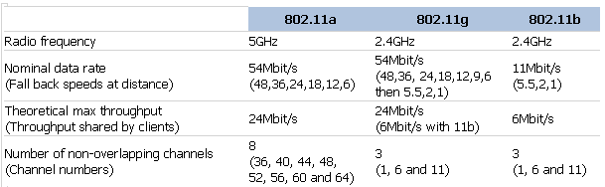
Figure 1 802.11 Specifications [1]

Note: - The 2.4GHz frequency is shared with other technologies; medical equipment, microwave etc. which can cause interference.

Each standard had its own benefits and drawbacks and dependant on what type of equipment was used support in later standards was sometimes built-in to allow backward compatibility.

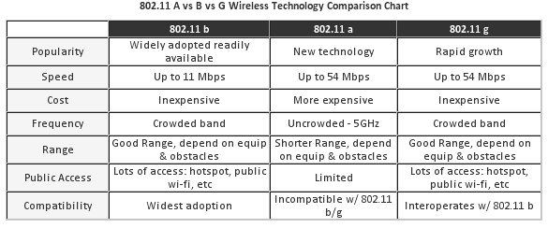
Figure 2 Wireless Standard Comparisons [2]

802.11n is one of the newest specifications and in comparison to the above can operate at over 300 Mb/s and uses both 2.4 and 5GHz frequencies using multi-in multi-out (MIMO) technology utilising extra antennas to send/receive data quicker also providing a greater range. Its drawback is that it can interfere with nearby b/g networks and may suffer from signal interference and is the most expensive option. Other specifications relate to other areas of wireless i.e. 802.11i Security extensions and 802.11e Quality of Service (QoS) etc.

Wireless networks usually operate in two distinct formats:
Adhoc | Infrastructure
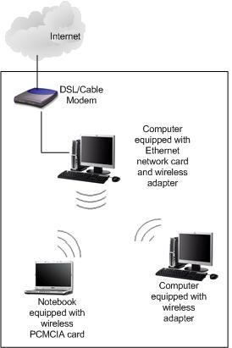 | 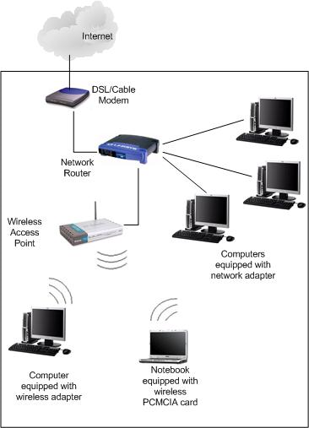
Each host passes across data to each other, de-centralised. | Using Access Points (AP) to centralise communication thus giving added security and more control.
Figure 3 Adhoc and Infrastructure Wireless Networks [3]
Wireless signals cannot be easily shielded and the signals can escape the confines of a building or area by varied means dependant on the nature of the building, thickness of walls/materials, atmospheric conditions etc, thus wireless signals can be subject to reflection, refraction and diffraction potentially allowing unwanted personnel to be able to gain access to wireless communications however, this phenomenon may also limit the spread of wireless signals requiring extra AP’s to be utilised to provide the right level of coverage.

AP’s advertise their services by broadcasting a so-called Service Set Identifier (SSID) akin to a domain name in Windows networks which identifies the network they offer services to, (a.k.a. Extended Service Set Identifier (ESSID)). Clients attempt to connect to the AP to access associated services.

Wireless networks can be either open (unsecured) or closed (employ encryption). There are numerous types of encryption formats utilised and of varied strengths (see later) requiring the client to know either a secret shared key or passphrase to connect to the WLAN via the AP.

1.2.2 RFID Overview

RFID uses RF based communications technology that exchanges data between small RFID tags (label or chip) and RFID enabled readers/ interrogators. Tags can take 3 forms, active, passive or battery assisted passive (BAP). At their simplest levels, the two latter require to be “woken” up by a reader interpret its request and then transmit a response. The response is interpreted through a database potentially allowing a further action to take place, i.e. open a door. [4]. RFID tags are radio transponders in that they receive and then automatically respond to the specific request. Readers are transceivers, using the same hardware to receive and transmit.

RFID uses a number of wavelengths and bands within the RF spectrum as defined by numerous ISO/IEC standards; each band has its own unique properties i.e. propagation of signal, size of antenna required so thus its own advantages and disadvantages:

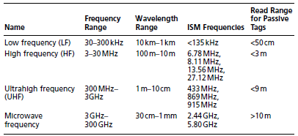
Figure 4 RF Ranges and Read Distances [5]

Tags and receivers generally have to be in close proximity to each other, more so passive tags which are woken up but can be read from more than 100m in certain circumstances.

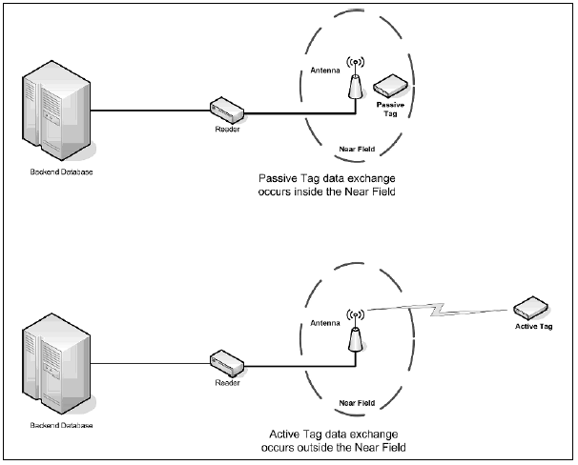
Figure 5 Passive and Active Tag Processes [4]

To allow further actions to occur, various Middleware (i.e. software) is required to make sense of the received data, which often passes on the information to a backend database or other program for further analysis.

Tags usually contain a unique ID (key) and a small amount of data (~65 KB - dependent on their Class) and can take three forms, read only, write once or rewriteable. Encryption can be used in certain types of tags to provide added security if required.

RFID technology is becoming a cheaper, scalable solution and is being used in a number of scenarios, examples include:

- Building Access Control
- Asset tracking
- Identification
- Point of Sale (POS).

1.2.3 Bluetooth Overview

Bluetooth has been around for a decade and is another relatively short range wireless technology that is used to transfer data between a computer and mobile phones, BlackBerry’s or Personal Digital Assistants (PDA).

It works in the same 2.4 GHz range as 802.11b and 802.11g wireless networks and uses 79 disparate frequencies which it hops across at 1,600 times per second. Its maximum data transfer rate is can be up to 3Mb/s and has a usual indoor range between 10-100m.
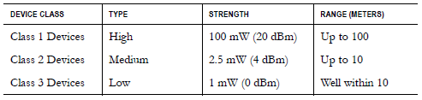
Figure 6 Bluetooth Classes [6]

Bluetooth devices that communicate with each other (pairing) are said to form a piconet, one device being the master whom all communications must pass through, the others the slaves with a maximum of 7 total devices.

A scatternet is formed by joining together 2 such piconets, which also has the benefit of extending Bluetooths maximum range. Bluetooth allows both data (Figure 3a) and two-way voice links (Figure 3b) to be formed dependent on how the scatternet is utilised. [7]

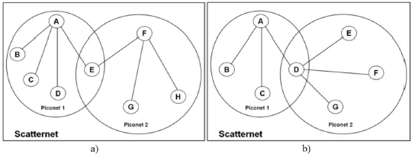
Figure 7 Bluetooth Topology [7]

Bluetooth devices can have different security levels:

- Silent – Never accepts connections.

- Private – No-discoverable, only accessible if their Bluetooth Device Address is known.

- Public – Discoverable and allows connections.

Coupled with these levels devices have three possible security modes:

- Nonsecure – No security enforced.

- Service-level enforced – A Non-secure asynchronous connection-less link is established; security is optionally established when certain requests are made.

- Link-level enforced – Security enabled when a connection is established using Logical Link Control and Adaptation Protocol (L2CAP). [7]

1.2.4 IrDA Overview

The IrDA specified a number of standards that relate to the transfer and exchange of data over infrared light using direct line of sight point-to-point connections. The term IrDA, used in the industry, actually relates to IrDA-Data, an IrDA standard which has a number of protocols defining how data is transferred between two devices. IrDA-Control, the other major standard defines how peripherals interact with varied host devices.

IrDA is an extremely cheap, easy, reliable solution to facilitate data transfer. Speed of transfer can range upwards from 115 Kb/s with SerialIrDA (SIR), through FastIrDA (FIR) at 4Mb/s, VeryFastIrDA (VFIR) 16Mb/s, the new IrSimple protocol at 4 - 16Mb/s and upward speeds of 100 - 500 Mb/s are in the planning and implementation stages. [8]

Generally IrDA data transfer takes place over small distances at less than 1m; at longer distances the bit rate very quickly attenuates with a maximum observed working distance at 3 km [9][10]. No security is in-built into this technology.

1.2.5 Other Wireless Technologies

There are a number of other wireless technologies but due to word-count limitations they will not form part of this report:

- Near Field Communication (NFC) – Using the 13.56MHz frequency allowing communication up to 212 Kb/s over distances of 20cm.

- Wimax – Utilised in Metropolitan Area Networks (MAN) at distances <50 km, with data rates to 70Mb/s, using the 10-66 GHz and 2-11 GHz frequencies.

- Mobile Phone Technologies utilised for data/ media transfers, notably GPRS, 3G and 4G etc.

1.3 Vulnerabilities

The first major thing to define is what a vulnerability actually is; usually defined as “a software or hardware bug or misconfiguration that a malicious individual can exploit.” [11]

Each separate wireless implementation technology will have its own distinct vulnerabilities discussed alongside the countermeasures that can be potentially deployed to improve its security. This will be with a view to reducing the inherent or future vulnerabilities and weaknesses found within it.
One way to ensure that wireless implementations are secure over and above the countermeasures that will be mentioned is the use of regular Vulnerability assessments (VA) and Penetration Tests. These, in conjunction with regular policy reviews and compliance and regulatory inspections should ensure that all current risks are known and can be mitigated against, as previously mentioned though these must be carried out regularly as threats can and do change. An initial VA and Penetration Test over wired/ wireless infrastructure should provide a baseline security posture for the network which can then be enhanced with varied countermeasures.

1.3.1 Wireless Vulnerabilities

A number of attacks can be performed against the WLAN due to in-built vulnerabilities within default setups and in certain types of implementation with certain protocols and encryption utilised notably:

- Network Discovery issues. – Default configuration settings, allow important information to be actively and passively discovered by such tools as Netstumbler, CAIN and Kismet either driving around (war-driving) or walking (war-walking) to try and discover wireless networks. This is due to the fact an access point automatically and regularly sends out beacon and informational packets including the SSID, Media Access Control (MAC) address, Vendor details etc beacons . This information can be used to further exploitation with later vulnerable issues:

Note: - 802.11w implements AES-CCMP encryption and authentication to unicast packets providing a layer of protection and until such time as hardware is upgrades the problem remains for broadcast packets.

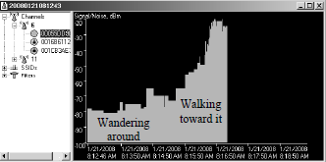
Figure 8 Wireless Discoveries with Netstumbler [12]

- Eavesdropping/Sniffing – Cleartext packet headers are transmitted by wireless networks and if no or weak encryption is used it may also be possible to gain information from the packets content, packets headers may provide details of what type of encryption is being used which may speed up an attack:

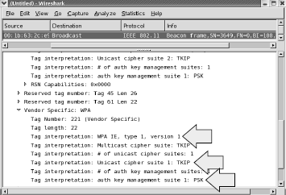
Figure 9 Packet Header Analyses [12]

Packet analysis may also show that encryption is in use for example using the fuzzy detection capability of such tools as Kismet:

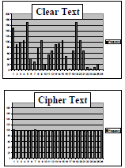
Figure 10 Kismet Fuzzy Detection Utility [12]

- Masquerading/Impersonation (Rogue AP) – Essentially the pretence of becoming a valid user by altering the MAC address of the attackers machine to that of a valid user. Alternatively and to cause more damage implementing particular software applications i.e. HostAP/Karma to pretend to be a valid AP in the network potentially duping multiple clients to connect thus stealing credentials etc. Information gained from network discovery and packet analysis previously will assist with this attack.

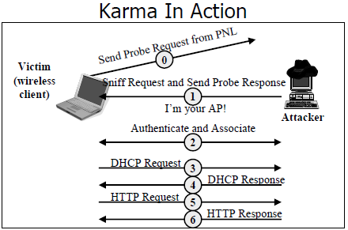
Figure 11 Karma setup as a Rogue Access Point [12]

- Man in the Middle (MiTM) – This is where an attacker will first “knock” a client off the WLAN, usually by sending de-authentication frames, the client will then try and re-associate, the attackers seeing this pretends to be the AP and the client associates with them, at the same time the attackers associates with the real AP thus any data between the victim and the real AP must go through the attacker and vice versa. Such tools as AirJack’s Monkey-jack are able to carry out this type of attack:

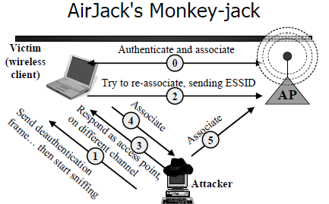
Figure 12 AirJack’s MiTM Attack [12]

Note: - This attack can potentially be spotted due to packet sequence numbers being incorrect.

- Denial of Service (DoS) – There are multiple vulnerabilities including:

  - Repeatedly receiving large specific types of packets i.e. management and control frames which are not protected, (specifically de-authentication and disassociation packets), essentially knocking and keeping clients off the network, carried out with tools such as void11 and fatajack:

  - Networks using WPA/WPA2 encryption after detecting a DoS attack will shut down the WLAN for a minute thus denying legitimate users access to the network and services. This was originally designed as a safety mechanism but can easily be used to repeatedly deny access. [7]

  - Networks using Extensible Authentication Protocol (EAP) may also be susceptible to such attacks with multiple EAPOL-Logoff, failure, start and success messages being sent. [13]

Note: - On WLAN’s no defence exists against DoS Attacks.

- Improper implementation of wireless security on access points. – Default security settings are inherently weak with access points having default passwords and no encryption enabled usually for ease of setup. Unnecessary services are usually also enabled by default some of which potentially use cleartext protocols i.e. ftp, http etc. that are able to be eavesdropped on.

- Cryptographic attacks – WLAN’s dependent on vendor implementations use a plethora of encryption mechanisms to secure their networks, several of which have major vulnerabilities associated with them:

  - Cisco Lightweight Extensible Authentication Protocol (LEAP). This is based on Microsoft’s MS-CHAPv2 protocol which is known to be weak and as such tools such as ASLEAP can be used to perform an offline dictionary based attack on sniffed EAP packets. [14]

  - Wired Equivalent Privacy (WEP) uses a flawed key generation mechanism called an initialisation vector (IV)[14] in its encryption process. The encryption bit length is either 40 or 104 bits long with 24 extra bits for the IV itself which is short and can easily be broken by such tools as Aircrack. WEP suffers from the following problems:

    - Colliding initialization vectors - IV’s are very often duplicated and sent in clear text, only 16,777,216 different values are possible.

    - Weak integrity checksum – Cyclic Redundancy Check 32 (CRC32) are performed by WEP which is not strong.

    - No replay protection.

    - Known clear text allows for attack against WEP keys – Packets contain embedded header information, an attacker can try and decrypt WEP keys based on this i.e. DHCP requests.[12]

Figure 13 Aircrack in action. [14]

WEP can be attacked in three different ways, Dictionary Attack, Traffic Inject and Weak IV analysis i.e. the Fluhrer, Mantin, and Shamir (FMS) Attack.

  - WPA is also vulnerable depending on how it is configured:

    - WPA1 & 2 with Pre-shared keys – Sniffing a 4-way handshake allows a slow dictionary attack to be performed.

    - WPA with PEAP – Open to brute force, MiTM and attacks against the backend Radius Server. [12]

- 802.11i specification issues – This standard allows both pre and post Robust Security Network Association (RNSA) methods to be used i.e. allows negotiation to a lower form of encryption being used potentially allowing the tricking of users into using less secure encryption methods. [13]

- Outdated firmware/software – Hardware once delivered if not patched with the latest firmware and software updates may leave it susceptible to wide ranges of exploits; remote code execution, buffer overflows etc. Large corporations/general users sometimes forget about small items of infrastructure and tend to concentrate on keeping the main corporate network updated via group policy, use of software update services.

- Race Conditions – WLAN’s alongside wired networks can be susceptible to race condition attacks. A victim requests a web resource from its AP whilst an attacker is sniffing network traffic, using tools such as Airpwn. The attacker sees the request and supplies a pre-configured “bogus” webpage before the AP can (whose page is thus ignored), this “bogus” webpage potentially contains links to malicious code potentially exploiting the client or causing nefarious actions to take place. Authentication is not required if encryption is not used in WLAN’s, Airpwn also works on WEP networks providing the key is supplied by the attacker.

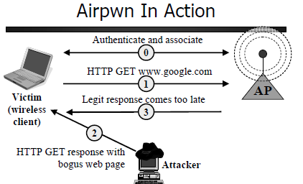
Figure 14 Race Condition attack using Airpwn. [12]

1.3.1.1 Wireless Countermeasures

Effective countermeasure against WLAN hacking include:

- Patching - Effective update and patching strategies for all firmware, software, operating systems (OS) and Antivirus products will alleviate against certain known vulnerabilities.

- Lockdowns – Employing strong Local/Group Security policies may secure client computers.

- Employment of Wireless Detection Systems (WIDS) may detect certain types of attacks:
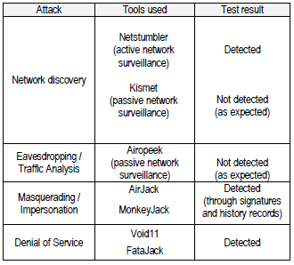
Figure 15 WIDS Detection Test [13]

- RSNA - Allows the use of strong authentication credentials\encryption possibly stopping some Masquerading/Impersonation attacks and in combination with using EAP may also limit the scope for MiTM attacks. [13][15]

- Cloak the SSID – This will not stop a determined attacker who can use numerous tools to identify the SSID but does provide another barrier for the network.

- MAC Address Filtering – Another security mechanism that can limit access to the WLAN to certain MAC addresses, however, as they are easily spoofed this is administratively intensive, an assessment of its benefits\protection afforded against its drawbacks should be made.

- User Education – Users need to be aware of the need for strong passwords and correct use of the highest compatible encryption. Combined with this, provide training on potential client side threats they may come across and the reporting mechanism they must adopt should they be compromised.

- AP Positioning – Positioned correctly wireless signals may not emanate outside the confines of the building, incorrect positioning leaves the AP open to potential external attackers.[16]

- Honeypots – Setting up bogus “open” AP devices in an attempt to lure and identify an attacker.

- Virtual Private Networks (VPN) – WLAN’s using encrypted VPN’s incorporating Transport Layer Security and IPSec provides an added layer of security. [16][17]

- 802.1x Remote Authentication and Dial-In User Service (RADIUS) Authentication services - A number of different implementations can be adopted dependant on the type of network utilised:

- EAP-TLS – Defacto standard for 802.11i networks and provides centralised port-based authentication and accounting. Digital certificates assigned by a trusted Certification Authority (CA) are used for authentication and key exchange (utilising dynamic WEP or TKIP) between server and client; successful authentication then allows access to the controlled port of the AP.
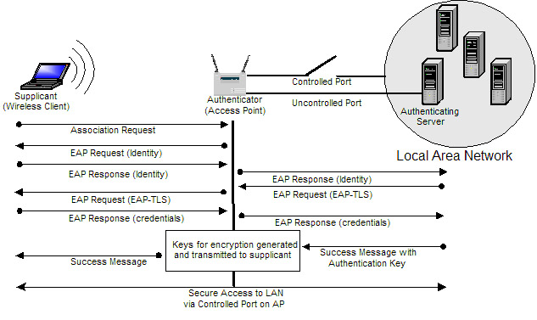
Figure 16 802.1X Authentication process using EAP-TLS [18][19]

Note: - This method may still be vulnerable to certain attacks specifically targeting RADIUS, WLAN DoS attacks; management frames are also still sent unencrypted. [14]

- EAP-PEAP (Protected Extensible Authentication Protocol) – A two stage authentication method whereby a TLS session allows authentication of the RADIUS server using digital certificates by the client, the second stage tunnels EAP traffic inside PEAP authenticating the client to the server. Initial key negotiation between the client and server then determines the master key used to encrypt the wireless traffic.

Note: - Using PEAP protects against offline dictionary attacks.

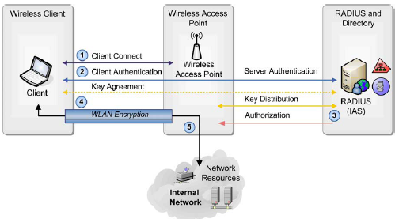
Figure 17 Securing Wireless LANs with PEAP and Passwords [20]

- EAP-TTLS – Similar to EAP-PEAP however in this implementation EAP messages are not encapsulated within the TLS session. The TLS payload in this case contains a number of attributes i.e. RADIUS EAP-Message attribute which provides the same functionality of EAP-PEAP implementations.

Note: - This method can provide a good solution as an intermediate proxy between legacy RADIUS servers.

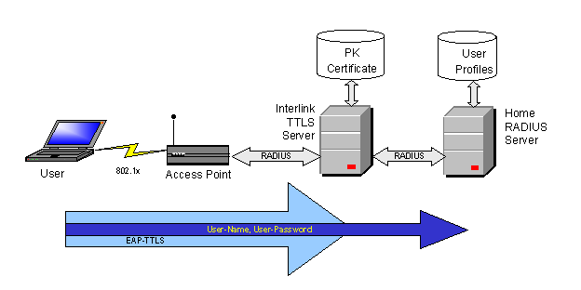
Figure 18 EAP-TTLS Proxy [21]

- Layer 2 Wireless Encryption – Employment of this provides end-to-end encryption from source to destination MAC address as is used and recommended by the US DoD. Access gateways facilitate connections between the client and AP reducing attack vectors dramatically. [14]

1.3.2 RFID Vulnerabilities

A number of vulnerabilities affect RFID notably:

- Spoofing – Supplying the reader with false information that appears valid.

- Insert Attacks –SQL injection techniques using SQL commands previously written to the tag; once read by the backend SQL based database malicious actions may take place. [5][22]

- DoS Attacks (Including Jamming) – RF noise is directed at the readers making the system unusable alternatively mass queries are made to the Object Naming Service (ONS) which works very similar to DNS. ONS when queried provides addresses of services where corresponding data of the Electronic Product Code is stored.[4][23]

- Replay Attacks –Scanners exist allowing a person to walk past a user/item with a RFID tag, scan the tag and then duplicate it allowing the successful use of the “duplicate” tag to gain access to areas/resources.

- Encryption Attacks – Low level bit encryption on tags can possibly be reverse-engineered and broken (MiFare Classic and the Crypto-1 Cipher). [24]

- Information Leakage – Tags can be read by unauthorised readers allowing the ability to track items/people and gather information. [25]

- Cloning – Software and hardware exists that can clone tags (British Passport [26]) and potentially alter data thereon i.e. reduce the POS value of an item for financial gain.

- Data Flooding – Numerous tags placed near the reader at the same time cause multiple reads, large quantities of information is then sent to the backend database. Alternatively Middleware buffers large amounts of data both cases potentially overflow the capacity of the backend database. [4]

- Viruses – Tag data may be manipulated that once read and passed to the backend database could cause remote code, exploit or nefarious actions to take place [4][27]

1.3.2.1 RFID Countermeasures

Effective countermeasures against RFID hacking includes:

- Patching – Including Middleware, OS and backend databases.

- Input Validation – Ensuring appropriate validation, analysis and sanitising of tag data by middleware programs and backend databases potentially protects against SQL, injection, virus attacks and spoofing.

- Shielding – Employing Mylar bags to ensure tags are not read in transit (or on the person), prevent tracking and replay attacks. [5]

- Encryption – To prevent cloning, spoofing etc:

  - Employ higher grade encryption in tags, replacing older less secure variants.

  - Ensure challenge response mechanisms are used to ensure that only this is sent across in the clear as opposed to the actual secret key.

  - Use “rolling code” schemes whereby the tag identifier changes after every scan making it difficult to mimic.

  - Cryptographically restrict tag read access by unauthorised readers.

- Database protection – Ensure the database is robust allowing large amounts of data to be received within a short space of time.

- Virus Protection – Ensure installed and regularly updated.

- ONS – Disallow external ONS queries or if required use VPN or SSL tunnelling. [4]

1.3.3 Bluetooth Vulnerabilities

A number of vulnerabilities affect Bluetooth notably:

- Blue-Jacking – Exploits Bluetooths “discovery” mechanism to send unsolicited anonymous messages to other devices.

- Blue-Snarfing/Stumbling – Silently, without the owners knowledge, connecting to another device, usually to access and copy data i.e. address book, calendar.

- Blue-Bugging – Serial connections made to other devices give the ability to control data services i.e. send/receive messages, make calls etc.

- Eavesdropping – Using Bluetooth to listen in to private communications.

- DoS – Intended to cause the device/service to crash/reboot.

- Viruses/Trojans/Worms – Infects devices and potentially cause harm to them, alternatively can be used to create wireless botnets that can be used for DoS attacks [28][29]

- War Nibbling – Using software mapping devices within an organisation attempting to enumerate:

  - Discoverable Devices,
  - Non-discoverable devices,
  - Service Information. [6]

1.3.3.1 Bluetooth Countermeasures

Effective countermeasures against Bluetooth hacking includes:

- Patching.

- Antivirus Mechanisms - Increase installed software diversity in devices slows the spread of worms etc. The use of counter-worms and segregation of infected devices may also play some part to guard against virus attack. [30]

- User Education – Alert users to the dangers involved in using Bluetooth.

- Deactivation – Switch off Bluetooth when not required.

- Hiding – Disable discovery on all devices.

- Firewalls – Utilisation of personal firewalls may give added protection for certain devices.

- Configuration Settings – Default settings should be changed especially the device name.

- PINS – Long and frequently changed PINS should be utilised to give added protection when “pairing”, in addition this should not be done in a public place.

- Security Policy – Effective, enforced and regularly reviewed.

- Scanners – Regular sweeps of areas may be able to identify rogue devices, identify devices that are enabled that should not be. [29]

- Encryption – Where possible encryption is to be utilised to protect communications. This may need to be carried out higher up the protocol stack.

- Audit – Regular reviews of the Windows registry may give indications of unauthorised access by illegal pairing with rogue devices.

- Bluetooth Honeypots – Similar to WLAN. [6]

1.3.4 IrDA Vulnerabilities

A number of vulnerabilities affect IrDA notably:

- Eavesdropping – It is possible to detect reflected light, filtering out any other surrounding ambient noise i.e. lighting, data then may be able to be retrieved.

- DoS Attacks – Crafted IrDA packets can be injected into the receiver to cause a DoS or reboot of the host device. [31]

- Privilege Escalation – Various exploits exist potentially allowing a local attacker to access data that would normally not be accessible to them as a low privileged user [32].

- No link-level security - All information is transmitted in an unencrypted format.[7]

Note: - Although not a vulnerability atmospheric conditions reduce the effectiveness of IrDA transmissions, which could alternatively be seen as a countermeasure against information leakage.

1.3.4.1 IrDA Countermeasures

Effective countermeasures against IrDA hacking includes:

- Physical Security – As IrDA attacks potentially require close access, a direct line of sight, within a 30◦ angle and limited distance, appropriate physical security methods may thwart eavesdropping and DoS attacks.

- Personnel Security - As above, effective vetting polices could preclude some attacks from disaffected/disgruntled staff.

- Protocol Security – Ensure supporting protocols provide adequate authentication, authorisation and encryption.

- Patching – OS and related applications.

2.0 Resources

Numerous resources on the Internet are available, many being open source, which will assist in identifying generic and specific vulnerabilities that currently affect wireless implementations. In combination these resources usually offer varied workarounds, lockdown and countermeasure guides that will assist the system administrator to secure their network from these threats.

These should be regularly researched and the knowledge contained can act as a countermeasure in itself as without this knowledge some systems administrators may not know that there particular implementation is insecure and for that matter the way to secure it.

2.0.1 Disclosed Vulnerability Information

Disclosed vulnerability information is available for previously identified vulnerabilities in wireless products and implementations from the following sources:

- The Common Vulnerabilities and Exploits (CVE) database run by the Mitre Corporation and provides a searchable resource on general vulnerabilities (http://cve.mitre.org/). [33]

- The Wireless Vulnerability and Exploits database (WVE) provides specific wireless related vulnerability information (http://www.wve.org/info).

2.0.2 Wireless Support Forums and Areas

Regular reviews of wireless vendors support areas and forums can assist an administrator to identify potential misconfigurations within the system and may also allude to vulnerabilities and lockdown and workarounds to secure them.

Note: - There are far too many vendors and support areas and forums to list.

2.0.3 Exploit Resources

Whilst vulnerability information etc. may be found from the above resources there are also a number of Internet sites that store exploit code, some even proof of concept that may be considered “0”day i.e. no prior warning of the vulnerability has been given, hence no way to guard against the exploit and thus possible access into your network. These sites can be hidden or possibly accessible via a pay service; however, some are open including Milw0rm, which is well worth a regular review from a countermeasure standpoint.

3.0 Conclusion

This report has discussed the many wireless technologies that are in use today, each has their own unique advantages and disadvantages dependent on their role and implementation. Wireless is by far an easier medium to configure, the problem lies with securing it.

Attacks against wireless can take many forms but usually are broken down into the following attack vectors:

- DoS (Jamming)
- Encryption Cracking
- Eavesdropping (Sniffing, incorporating Information Leakage)
- Cloning
- Masquerading (MiTM incorporating Replay attacks)
- SQL Injection

The following is not attacks per see but never the less can have an adverse affect on the security of the system:

- Misconfiguration
- Default System Passwords

As with any industry and technology as time progresses new types of vulnerabilities and attacks will evolve, these will need varied countermeasures applied to mitigate them but that said operating what is regarded as a safe wireless implementation one month may not be regarded as safe the next due to a newly discovered attack. As such the need to carry out research, initiate an effective patching regime, amend configurations to make them more secure and continued user education is an ongoing task that must be carried out to keep your implementation secure.

As an attacker will find ways to break into a system novel solutions may be required to secure them, this said, old school practices of physical, personnel other security measures should also be adopted to provide a defence in depth approach to securing the wireless network.

4.0 References:

- RM, (2009) “Appropriate channels for use on a wireless network” Available online from: http://www.rm.com/Support/TechnicalArticle.asp?cref=TEC597527 [Accessed 24 Oct 09]
- Netkrom Technologies Inc (2009) “Wireless Frequency Spectrum”
- Available online from: http://www.netkrom.com/wireless_frequency_spectrum.html [Accessed 24 Oct 09]
- Association for Progressive Communications (APC) 2009 “Wireless technology is irreplaceable for providing access in remote and scarcely populated regions”
Available online from: http://www.apc.org/en/news/strategic/world/wireless-technology-irreplaceable-providing-access [Accessed 24 Oct 09]
- Home-Network-help.com (2009) “What is Wireless Network “Available online from: http://www.home-network-help.com/wireless-network.html [Accessed 24 Oct 09]
- Kleinschmidt, John et al, (2006) “RFID Security” Syngress.
- Sanghera, Paul et al, (2007) “How to cheat at – Deploying and securing RFID” Syngress.
- Whitehouse, Ollie, (2003) “War Nibbling: Bluetooth Insecurity” @STAKE INC.
- Haataja, Keijo, (2006) “Security in Bluetooth, WLAN and IrDA: a comparison” University of Kuopio
- IRDA, (2009) “IRDA” Available online from: http://www.irda.org [Accessed 24 Oct 09]
- Communications Security Establishment Canada, (2009) “Preliminary Vulnerability Assessment of Wireless LANS” Available online from: http://www.cse-cst.gc.ca/its-sti/publications/itsg-csti/itsg14-eng.html [Accessed 24 Oct 09]
- Microsoft, (2009) “IRDA – Background and Overview” Available online from: http://msdn.microsoft.com/en-us/library/ms810617.aspx [Accessed 24 Oct 09]
- Gatford, Chris, Gold, Andre, Manzuik, Steve, (2007), “Network Security Assessment – From Vulnerability to Patch” Syngress.
- SANS, (2008) “SANS 560 - Network Pen Testing & Ethical Hacking” SANS
- Alexandros Tsakountakis , Georgios Kambourakis , Stefanos Gritzalis, (2007) “Towards effective Wireless Intrusion Detection in IEEE 802.11i” Third International Workshop on Security, Privacy and Trust in Pervasive and Ubiquitous Computing (SecPerU 2007) July 2007 pp. 37-42
- Kindervag, John, (2006) “The Five Myths of Wireless Security” Telecommunications and Network Security Sep/Oct 2006
- Jyh-Cheng, Yu-Ping Wang, (2005) “Extensible authentication Protocol (EAP) and IEEE 802.1.x: tutorial and empirical experience” Communications Magazine, IEEE Volume 43, Issue 12, supl.26 – supl.32, Dec 05
- Lawan A. Mohammad, Biju Issac (2008) “Vulnerability Analysis and Defenses in Wireless Networks” Handbook of Research in Wireless Security IGI Global
- Badra, Mohamad, Hajjeh, Ibrahim, (2006) “Enabling VPN and Secure Remote Access using TLS Protocol” 2006 IEEE International Conference on Wireless and Mobile Computing, Networking and Communications June 2006 pp. 308-314
- Interlink Networks, (2007) “Configuring EAP-PEAP & EAP-TTLS for a RADIUS Server” Available from: http://www.interlinknetworks.com/app_notes/eap-peap.htm [Accessed 24 Oct 09]
- Hurley, Chris et al (2004) “WarDriving: Drive, Detect, Defend: A Guide to Wireless Security” Syngress
- Microsoft, (2009) “Securing Wireless LANs with PEAP and Passwords” Available from: http://www.microsoft.com/downloads/details.aspx?FamilyID=60c5d0a1-9820-480e-aa38-63485eca8b9b&displaylang=en [Accessed 24 Oct 09]
- United Business Media, (2009) “New RFID Attacks opens the door” Available online from: http://www.darkreading.com/security/encryption/showArticle.jhtml?articleID=208804432 [Accessed 24 Oct 09]
- RFID-ASIA, (2007) “Putting RFID Network Security in Perspective” Available online from: http:// www.rfid-asia.info/2007/02/putting_rfid_network_security_in.htm# [Accessed 24 Oct 09]
- Computerworld inc, (2008), “RFID Hack could crack open 2 billion smart cards” Available online from: http://www.computerworld.com/s/article/9068644/RFID_hack_could_open_2_billion_smart_cards [Accessed 24 Oct 09]
- BlackHat, (2007), “RFIDIOts!!! RFID Hacking without a soldiering iron” Available online from: http:// www.blackhat.com/presentations/bh-europe07/Laurie/Presentation/bh-e-07-laurie.pdf [Accessed 24 Oct 09]
- Guardian Unlimited, (2006) “Arphid Watch: Find Own Foot, Aim Hastily, Pull Trigger” Available online from: http:// www.wired.com/beyond-the-beyond/2006/11/arphid_watch_fi/ [Accessed 24 Oct 09]
- RFIDVirus.org, (2006) “RFID Viruses and Worms” Available online from: http://www.rfidvirus.org/vulnerabilities.html [Accessed 24 Oct 09]
- Hernacki, Brian, (2006) “Improving Bluetooth Security: What IT Managers and Mobile Users Can Do” Telephone and Network Security Sep/Oct 2006
- Guanhua, Yan , Eidenbenz, Stephan (2006) “Bluetooth Worms: Models, Dynamics, and Defense Implications” 22nd Annual Computer Security Applications Conference (ACSAC'06) December 2006 pp. 245-256
- Microsoft, (2009) “MS Security Bulletin MS01-046” Available online from: http://www.microsoft.com/technet/security/bulletins/ms01-046.aspx [Accessed 24 Oct 09]
- Mitre.org, (2009) “CVE-2009-3002” Available online from: http://cve.mitre.org/cgi-bin/cvename.cgi?name=CVE-2009-3002 [Accessed 24 Oct 09]
- Orrey, Kevin, (2009) “Application Testing – Citrix Application Server” University of Bedfordshire Independent Study Module.

